|  |  |  |  |
| --- | --- | --- | --- |
| **Procedure:** | Centralised Investment Proposition | **From (date):** | 2023 |
| **Replacement?:** | Y | **Produced by:** | Essentials |
| **Signed off by:** | (SMF16) | | |

**Centralised Investment Proposition**

**Contents:**

1. Background

2. client proposition

3. Platform selection

4. Centralised Investment Propositions

5. Shortlists for Centralised Investment Propositions

6. Multi-asset funds / products

7. Next steps

**Appendix 1 –** DFMs reviewed

Appendix 2 – Platform analysis

Appendix 3 – Platform charges analysis

Appendix 4 – Bespoke DFM comparison

Appendix 5 – Scopic report (Cornelian Multi-asset funds)

Appendix 6 – SEI Funds

Appendix 7 – Prufund

**1. Background**

ABC IFA Ltd is a financial planning business based.

The business provides financial planning services for around xxx clients who are actively serviced. (are there any inactive clients?). Current assets under management is approximately £60-70 million.

ABC IFA use a range of platforms and providers are keen to undertake a piece of work to review this and ensure that the appropriate due diligence documentation is in place and that a consistent approach to the recommendation of platforms and investments is adopted going forward.

**2. ABC IFA client proposition**

ABC IFA offer services for clients with both ‘simple’ and ‘complex’ needs. The service proposition is broadly similar across the client bank with at least an annual review being offered, a quarterly newsletter and unlimited access to the financial advisers. For the provision of the service, ABC IFA charge 1% per annum of assets under advice.

The investment proposition delivered will differ based on the specific needs of the client and is as follows;

**2.1 Discretionary Bespoke Portfolios:** Typically clients with more than £750,000 to invest are offered the opportunity for a Discretionary fund Manager to manage those investments. The amount invested is simply a guideline as the adviser would also consider whether the client had any specific requirements e.g. management of CGT, specific income requirements or any investment inclusions/ exclusions required in the portfolio.

In addition, if a SIPP was being used specifically for property purchase then typically a non platform SIPP e.g. Standard Life, XABC would be recommended plus a DFM selected to manage any investments or a fund solution.

**2.2 DFM model portfolios on a platform:** Clients with complex requirements such as a range of tax wrappers, drawdown but also have a focus on cost are typically offered the Nucleus platform and a DFM model portfolio provided by Tatton Investment Management or a blend of funds.

**2.3 Standalone Product/ Investment:** Clients who have been identified as having ‘simple’ needs where the solution is a standalone product (e.g. Bond, ISA or Pension) are offered a product and combined investment solution.

Typically these clients are cost conscious and this would influence the decision as to the product/ investment solution offered. These clients also require an investment solution whereby the investment does not require any ongoing management by ABC IFA but remains aligned to the risk profile or the specific requirements of the client.

There are also some clients on legacy platforms such as Standard Life where Tatton cannot be accessed. These have traditionally been offered a fund solution and the current panel of these will be reviewed.

This review will therefore cover three key investment propositions:

1. Bespoke DFM portfolios (for clients with complex needs and typically more than £750k to invest)
2. DFM models on platform (for clients with complex needs who do not require an outsourced DFM solution)
3. Multi-asset funds/product solution (for clients with simple needs and legacy clients)

**3. Platform Selection**

Whilst the key focus of this review is the investment proposition, the choice of platform has also been considered.

**3.1 Regulatory Position – Use of platforms**

During the last few years there have been numerous FCA publications which have referred to due diligence of platforms and investment propositions.

The IFA factsheet published in 2011 titled ‘Platforms using fund supermarkets and Wraps’, highlighted that there are nine areas which an IFA should consider when making their platform decision:

* The platform provider
* Terms and conditions of using the platform
* Charges - including the actual cost, charging structure and transparency of charges
* Range of funds, tax wrappers and other products available
* Range of asset classes
* Functionality
* Accessibility
* Additional tools
* Support services

In August 2011, the FCA issued Policy Statement PS11/9 (Platforms: Delivering the RDR and other issues for platforms and nominee-related services). Annex 3 of this provided clarification around the use of platform-based investments, the independence rule and in particular the use of a single platform.

The FCA believe that ‘it is likely to be very rare, if possible at all, that a firm could use one platform for all clients and meet the independence rule’. In addition, they state that ‘firms need to be mindful of their duty to comply with the suitability requirements and the client’s best interests….firms will need to be able to identify clients for whom a particular platform-based service is not suitable and advise them ‘off-platform’.

In April 2013, the FCA published PS13/1 which banned cash rebates in the majority of circumstances and least to the introduction of clean share classes and in 2014 Pensions freedom regulation was announced whereby platforms in particular amended their propositions in order to offer the appropriate products for financial advisers and their clients.

With the above in mind, ABC IFA typically use Nucleus and Parmenion but also offer a product solution where the additional functionality and resultant cost is not incurred. In addition, some legacy clients are on other platforms e.g. Standard Life. The position with these clients is under regular review but they will not be transferred unless Nucleus or Parmenion is clearly a more suitable option.

A key thematic review was also published by the FCA in February 2016 of TR16/1 ‘Assessing suitability: research and due diligence of products and services’.

Despite its brevity, the review gave some clear guidance around the FCA expectations.

The report is not specific to platforms and covers ‘products and services’ but the following are important to note as indicators of future guidance:

**Avoid ‘status quo bias’** – whilst a firm might be comfortable with their platform selection, there shouldn’t be an assumption that ongoing due diligence is therefore not required.

**Process** - Adopt a structured approach to research and due diligence with a range of clear criteria to assess enabling your platform selection to be truly objective. (This due diligence reports reflects this recommendation.)

**Suitability** - Ensure that any recommendation made is suitable for the client. (ABC IFA is responsible for suitability but has clear guidelines as to when the client is offered each platform and investment proposition)

**Data** -Information used for research and due diligence should be gathered from a range of sources and not just the providers. (Data for this report is sourced from a number of areas: Financial adviser articles, Defaqto, Platforum, QPS data, due diligence documents issued by the providers)

In addition, the firm needs to ensure that there are no conflicts of interest between the clients and those of the firm. The example given was that service should not be considered as an over-riding factor when selecting a platform and a firm should not place the service they receive from the platform above that being delivered to the client. (Whilst service ratings have been considered, they are only one criteria being taken into consideration for platform selection).

ABC IFA believe that undertaking this process will ensure that the business complies with TR16/1.

**Platform (Product) due diligence including the framework for product use and selection is contained separately.**

1. **Centralised Investment Propositions**

**4.1 Methodology**

The following methodology has been used to support the review of the centralised propositions for each segment:

|  |  |  |
| --- | --- | --- |
|  | Conversation with ABC IFA to identify all strategic criteria and detailed requirements of their investment proposition |  |
|  |  |  |
|  | Analysis of the investment market to produce a shortlist of investment propositions which meet the high level strategic requirements and agree the overall nature of the investment proposition |  |
|  |  |  |
|  | Analysis of the capability of providers to meet the detailed and operational criteria |  |
|  |  |  |
|  | Production of the due diligence report and associated documentation |  |

**4.2 Requirements and Regulation**

ABC IFA are keen where possible to have a standardised approach to client investments but are very aware of the FCA Final Guidance issued July 2012 ‘Assessing suitability: replacement business and Centralised Investment propositions’ where the FCA warn against:

**Shoe horning** – Recommending a ‘one size fits all’ solution which is not suitable for the individual needs and objectives of a client. Essentially the adviser still needs to ensure that if they have a range of clients and the use of their selected CIP should not be an ‘automatic’ solution for their clients.

**Churning and ensuring suitability** – The firm must give adequate consideration when switching into a CIP that adequate consideration has been given to whether this is both suitable and in the client’s best interest. The FCA indicates that adviser firms need to ensure that their advisers can identify when a CIP is not suitable investment for the client.

**Charges** – The use of a CIP might result in higher (and potentially less transparent charges) than the client’s existing investments and with few additional, actual benefits.

**Additional charges e.g. trading and dealing** –Many platforms will charge trading and dealing charges for assets such as investment trusts, ETFs etc. and these need to be considered, particularly when working within a model portfolio environment. For example, trading charges are often around £10.00 per transaction. If the client was paying a regular premium of £100 per month into a portfolio containing 5 ETFs, then the trading charges would amount to 50% of the contribution.

**Performance** – Performance should be considered prior to moving client investments and the Adviser must be able to justify why in their opinion the new investment is likely to outperform the existing one.

**Tax implications** – The firm must consider whether the replacement investment is more tax efficient in light of the clients’ financial needs and objectives and also must consider any tax implication of switching e.g. Capital Gains Tax

**Appropriate controls and processes in place** – The IFA firm needs to have adequate oversight arrangements and management information (MI) to mitigate the risk of unsuitable advice.

As a result of the above, it was deemed important to have a range of investment solutions for clients, understand the charges and ensure transparency (e.g. any dealing charges), performance and tax efficiency.

**5. Shortlists for Centralised investment propositions**

**5.1 Bespoke DFM Proposition Requirements and DFM models on platform**

The key requirements for ABC IFA when selecting a DFM to provide bespoke portfolios or models on platform are as follows:

**Relationship:** ABC IFA are keen to work with an investment business where a close working relationship can be put in place. They require regular face to face support and a dedicated point of contact to address any enquiries as quickly as possible

**Size:** ABC IFA are keen to work with a DFM who has achieved some scale in the market which should indicate quality of proposition and potential longevity. Any DFM with less than £0.5bn under management will therefore not be considered.

**High quality service:** ABC IFA pride themselves on providing a high quality service for their clients and therefore want to work with providers who can continue to support that and ensure that client satisfaction remains at a high level.

**Alignment to the risk tools and processes used**: ABC IFA are using Distribution technology and it is therefore important that any outsourced investment provider is prepared to align their solution to this.

**Platform availability:** ABC IFA use Nucleus. Any DFM model portfolio solution therefore must be available on this platform.

**Demonstrable track record:** ABC IFA wish to work with a providers who have a track record in the investment industry. Whilst past performance is not a guide to future returns, ABC IFA believe that this should still be reviewed and also a 5 year track record is preferable.

**Bank Proposition** – ABC IFA prefer to exclude a DFM which is either a private bank or subsidiary of a bank.

Based on experience form previous DFM projects, Discus have been informed and have observed that over time portfolios tend to start to contain an increasing number of ‘bank related products’ e.g. Structured Products and ABC IFA are not comfortable with this approach.

**Cost competitive:** Whilst charges are not the primary consideration, ABC IFA want to deliver an investment proposition which is cost competitive and value for money.

**ARC Subscription** – Asset Risk Consultants (ARC) is an independent firm specialising in reporting and consultancy services for charities and investment institutions.

The ARC Private Client Indices (PCI) provide insight into the actual returns being generated by Investment managers for Discretionary Private client portfolios based on real performance numbers and levels of risk appetites.

The monitoring and reporting of performance for private client portfolios is often a challenge for both DFMs and potential clients (IFAs and Direct clients). Therefore ABC IFA believe that if a DFM subscribes to the ARC indices and are prepared to report performance publicly is an important factor in the selection process.

**Transparency of charges:** Given the FCA position on charges, it is important that any investment proposition has clarity around the various charges being imposed e.g. funds, platform, investment management, VAT etc. This enables ABC IFA to analyse whether the client is likely to be moving to a CIP where charges are an advantage.

**Independent of any other financial organisation**: ABC IFA have a preference to work with an investment provider who is not an asset manager and is independent of an asset management business. As a result the provider will not have any bias towards inclusion of their own funds in any investment propositions.

**5.2 Shortlist of DFM model portfolio options on Nucleus**

Nucleus have over 35 DFM options available on the platform. Of the above features for model portfolios ABC IFA are keen that a DFM model portfolio proposition can offer the following:

* Range of portfolios to ensure suitability for clients including variety of risk rating and styles e.g. active/ passive/ income/ growth/ ethical
* Competitive costs
* Minimum investment which is not prohibitive
* Local support

In order for a business to remain independent, the selection of DFM propositions does not require to be made from whole of market as they are a service and not a Retail Investment Propositions. The regulator however expects to see that an IFA has considered a range of propositions before narrowing the panel.

As a result, the shortlisted DFMs for consideration and analysis for model portfolios are:

* Tatton Investment management
* Investec
* Brooks Macdonald
* Brewin Dolphin
* Quilter Cheviot

These have been compared against the criteria in section 5.1 in the table below:

|  |  |  |  |  |  |  |  |
| --- | --- | --- | --- | --- | --- | --- | --- |
|  | **Range of portfolios** | **Cost (Bps)** | **Minimum investment** | **Relationship** | **Size** | **Aligned to DT** | **Track record > 5 years** |
| Tatton IM | 24 | 24 | IFA min | Local support | £4bn | Yes | Yes |
| Investec | 6 | 125 | £40k | Local support | £32.6bn | Bespoke to IFA business | Varies depending on portfolios |
| Brooks Macdonald | 9 | 60 | £10k | Local support | £8.3bn | Yes | yes |
| Brewin | 6 | 36 | £10k | Local support | £28.9bn | Yes | Yes |
| Quilter Cheviot | 5 | 36 | £200k | Local support |  | Yes | Yes |
| 7IM | 6 | 30 | £200k | Local support | £10bn | Yes | Yes |

Tatton IM has been selected for the following reasons:

* Largest platform only DFM in the UK market
* Wholly focused on delivering the appropriate investment and service proposition to financial advisers in order for them to deliver their proposition to end clients
* Cost competitive (underlying management charge of 0.15%)
* Range of portfolios in terms of risk and style

It is also worth highlighting that despite only recently achieving a full 5 year performance track record, the Tatton portfolios received a 5 star Defaqto award after 3 years.

A full range of fund fact sheets is available which have been indicated the following performance compared to the IA Flexible Investment peer group:

|  |  |  |
| --- | --- | --- |
| Fund | 1 year performance v benchmark | Since inception |
| Managed balanced | Ahead | Ahead |
| Managed defensive | Behind | Ahead |
| Managed aggressive | Ahead | Ahead |
| Managed Cautious | Behind | Ahead |
| Managed Active | Ahead | Ahead |

Whilst remaining as the platform model portfolio solution of choice, it would be worthwhile maintaining an eye on performance but also the risks and controls within the business as it continues to increase in size.

In order to address this, the Due Diligence documentation from Tatton IM was requested and reviewed and this is in order. GH also met with Helen O’Neill, COO for Tatton IM and discussed model portfolios on platform. Helen offered to set up any further meetings required e.g. with the Head of Compliance. However, as a result of this meeting I believe that we have addressed any questions regarding Tatton Investment Management which may currently have been raised in the market.

The Adviser Centre were also asked to review the portfolios to comment on the investment selection and how the portfolios performed in relation to this. The Adviser Centre stated that they know the team at Tatton well and that the investments being used within the portfolios gave no cause for concern and were performing as expected.

**5.3 Shortlist for the provider of DFM bespoke portfolios**

Based on the requirements in section 5.1 over 120 DFMs were considered for the panel (Appendix 1 provides this list). DFMs from this list were then excluded from the process as they failed the criteria agreed for assets under management or bank related proposition.

In addition, a significant number of DFMs then failed the criteria as they currently do not subscribe to ARC.

This reduced the original list to the following first shortlist of 11 DFMs:

* Brooks MacDonald
* Brewin Dolphin
* Cazenove
* Charles Stanley
* Close Brothers
* Investec
* Quilter /Cheviot
* Rathbone
* Smith and Williamson
* Standard Life Wealth
* Seven IM

However, ABC IFA have a requirement to offer bespoke portfolios for clients with over £750k to invest (if appropriate) As a result this would further remove Close Brothers and Standard Life Wealth as they require £1m and £500k respectively to be invested.

In addition, 7im work on a ‘model basis’ where the service rather than the investment proposition to the client is bespoke (they are unable to include/ exclude at stocks and shares level for example). As a result these have been removed from the list and the final shortlist is as follows:

* Brooks MacDonald
* Brewin Dolphin
* Cazenove
* Charles Stanley
* Investec
* Quilter /Cheviot
* Rathbone
* Smith and Williamson

The next stage of the process is to compare both DFM model portfolios and Bespoke DFM propositions against the detailed requirements.

**5.4 Detailed Requirements for DFM propositions**

The detailed requirements agreed with ABC IFA for the DFM investment propositions are as follows:

* Bundled model for pricing should be available – i.e. inclusive of all dealing and trading charges.
* Integration with Intelliflo for data feeds
* Charges (i.e. DFM management charge and adviser charge) - ABC IFA typically charge 1.00% on client assets for their service and aim to have a charge which is as close as possible to 2.00% (plus VAT). There will be an additional charge for the underlying investments which will vary depending on the investment instruments being used by the DFM within the portfolio.
* Portfolios should not contain DFM ‘in-house funds’
* At least half yearly reports available for clients moving to quarterly post MiFID II
* Clients should be able to meet with ABC IFA and the Investment manager at least annually and preferably half yearly
* Suitability to be responsibility of ABC IFA (i.e. ABC IFA undertake the risk profiling of the client and the investment mandate/risk budget is passed to the DFM for them to select and manage the appropriate investments)
* Commitment to the IFA market

In order to assess the shortlist DFMs against the detailed requirements, data was sourced from:

* Due Diligence Documentation provided by the DFMs
* Meetings/ phone conversations with DFMs to ensure full understanding of their responses
* Email correspondence in relation to specific questions

**5.5. Analysis of shortlist against detailed requirements**

Further to the analysis as outlined in Appendix 4 the following DFMs were excluded.

|  |  |
| --- | --- |
| DFM | Reason for exclusion |
| Cazenove | Inability to provide a bundled model  Inability to pass data feeds to Intelliflo  Only 8% of business currently from IFAs (but growing) |
| Rathbone | No current integration with B/O systems  Responsible for suitability  Relatively low level of business from IFAs |
| Charles Stanley | Small presence in Scotland with only one investment manager and would therefore prefer to wait until this operation builds some demonstrable scale  Low presence in IFA market in general  Preference for fees an additional charges than a bundled model  No integration with back office systems  Relatively expensive v alternative options |
| Smith & Williamson | No back office integration at present  Preference for a fee plus additional charges model  Portfolios appear competitively priced but based quoted based on equities only and in reality the costs are higher  Low IFA presence currently |

Table 5

This leaves the following DFMs for the panel.

* Brewin Dolphin
* Brooks MacDonald
* Quilter/ Cheviot
* Investec

The following outlines the charges for each of the DFM services (excluding any additional cost of investments)

|  |  |  |  |  |
| --- | --- | --- | --- | --- |
| DFM | Brewin Dolphin | Brooks MacDonald | Investec | Quilter/ Cheviot |
| DFM Charge | 0.8% plus VAT on first £1m 0.6% plus VAT on next £1m and 0.40% plus VAT on next £3m plus transaction charges | 0.75% plus VAT | 1.0% up to £1m  0.75% on next £1.5m  0.60% thereafter  Or  0.75% plus dealing commission | 1.0% up to £1m  0.5% on next £1.5m  0.49% on next £3m  0.30% thereafter |

Table 7

The analysis of DFM service charges demonstrates that the selected panel DFMs are broadly similar. Quilter Cheviot are slightly more expensive which particularly impacts any larger portfolios so it is recommended that ABC IFA have a discussion around this with them.

**Performance**

The following table looks at a balanced portfolio over 1/3/5 years compared to the PCI index (figures at September 2017) and demonstrates that all DFMs are performing above the appropriate ARC

benchmark.

|  |  |  |  |
| --- | --- | --- | --- |
|  | **1 year** | **3 years** | **5 years** |
| **ARC Cautious** | **6.1** | **5.6** | **4.2** |
| Investec | 7.2 | 6.2 | 7.0 |
| ARC Balanced | 4.3 | 17.7 | 33.8 |
| Brooks Macdonald | 5.5 | 19.90 | 38.17 |
| Quilter Cheviot | 7.10 | 19.68 | 39.60 |
| Brewin Dolphin | 7.2 | 21.5 | 37.4 |

**5.6. Conclusion – DFM Panel**

The final recommendation is that the core panel should comprise:

* Brewin Dolphin
* Brooks MacDonald
* Quilter/ Cheviot
* Investec

**6. Multi asset funds / products**

ABC IFA currently use a panel of funds in the following circumstances:

* Legacy clients on Standard Life Platform
* No requirement for a platform and a fund/product solution is required or clients on Nucleus or investment in a SIPP require a fund solution

**6.1 Legacy clients** on Standard Life platform where access to Tatton models are unavailable. There are plans for an OEIC to be developed and at that point the use of this will be reviewed. Whilst the preference for new clients is typically to move to Nucleus and Tatton model portfolios, there may be reasons why the client should remain on Standard Life and therefore a panel of funds are available for advisers to select from.

When selecting the appropriate fund solution for a client, the following are considered by the adviser:

**Cost** – Funds may be used in isolation or blended if there is a requirement to lower the cost for the client.

**Performance** – Whilst past performance is not a guide to future performance it does give an indication. At the point of reviewing fund options for clients then performance will be considered and if there are any concerns then these would be taken into account when recommending the investment solution to the client.

**Style** – The funds on the panel have a range of styles e.g. active / passive and there are additional options such as ‘unconstrained’ which can address volatility concerns.

**Blend** – If a blending option is being used for the client then all of the above are taken into consideration for example a higher cost fund typically active is likely to be blended with a lower cost passive fund.

**Fund Options:**

**Cornelian multi-asset risk managed funds** – These are used where clients require an actively managed solution but also like the unconstrained nature of the funds. This means that they don’t sit within any IMA sector and adhere to benchmarks. As a result, where market conditions dictate, risk can be removed by moving to cash.

The challenge is that whilst producing good returns, the funds are relatively expensive at 1.1-1.3% total TER. As a result if the client is cost conscious these might be blended with lower cost passive funds.

The Cornelian funds are a suite of 5 multi-asset portfolios that invest in direct securities, open ended actively managed funds, investment trusts and ETFs. The aim is to manage each portfolio’s expected volatility so that it remains below an upper ceiling as suggested by an optimised model managed by Distribution Technology (DT). The approach is tactically active and positive return oriented – with each fund also having its own inflation-plus return objective (net of fees), with these targets being progressively higher as the expected volatility ceilings for each portfolio increases. The timeframe for achieving the strategy is over 5 to 7 year rolling periods.

The 5 funds listed below all have an ‘A’ rating from Scopic Appendix 5 summarises the full report which is available as a separate appendix and covers the appropriate company and fund information.

* Defensive fund
* Cautious fund
* Managed Growth fund
* Growth fund
* Progressive fund

**Vanguard life strategy funds**

Vanguard was founded in the US in 1975 and has over 20 million investors and $4.7 trillion under management. The Company is a Mutual which is owned by the US funds and ETFs and in turn therefore owned by the investors.

The Vanguard Life Strategy funds were launched 6 years ago in order to give investors access to a diversified portfolio at low cost through the use of Vanguard’s low cost index funds.

The funds are typically use by ABC IFA to blend with Cornelian multi-asset funds in order to reduce the total cost to the client) in addition to being a low cost solution with OCFs at 0.22% (reduced from 0.24% in January 2017).

The funds are also straightforward in their operation i.e. the blend of equities and bonds are rebalanced quarterly on an automated basis which rebalances risk, return and cost.

The funds are positioned as having a straightforward design, low investment costs and exposure to a mix of equity and fixed income investments and low maintenance.

There are 5 funds with stepped exposure to diversified global portfolios of equities and fixed income with the naming convention reflecting the level of equity holdings e.g. 20%, 40%, 60%, 80%, 100% which is aligned to the client ability to take risk. However overlayed with this is a time horizon.

The funds are built on passive strategies and Vanguard themselves indicate that they ‘may serve as suitable accumulation components for a broader investment programme’.

**SEI funds**

SEI is a global business which started in 1968. It has £236bn under management and over 8,600 clients. Their aim is to find the best managers to invest client money and therefore operate under a manager of manager structure and adopt a goals based investment approach.

The SEI funds have traditionally been a mid-range cost option for legacy clients particularly for clients with a medium risk profile. Typically they have been used as a low volatility solution.

The range comprises 7 funds designed either with a stability focus or growth focus (Appendix 6 summarises these)

The following table outlines the charges:

|  |  |  |
| --- | --- | --- |
| Fund | OCF | AMC |
| SEI Defensive fund | 0.78% | 0.50% |
| SEI Conservative fund | 0.87% | 0.60% |
| SEI Moderate fund | 0.89% | 0.655 |
| SEI Core fund | 1.05% | 0.80% |
| SEI Balanced fund | 1.10% | 0.85% |
| SEI Growth fund | 1.15% | 0.90% |
| SEI Aggressive fund | 1.13% | 0.90% |

The portfolios have a high level of diversification across up to six asset classes – equity, fixed income, inflation sensitive, income, liquidity and absolute return and a key differential is selection of investment products including institutional and boutique managers not usually available to the retail market.

Managers are selected to manage a specific mandate and then their philosophy, process, people and performance and continually monitored to ensure that portfolios are aligned to the overall strategy.

As a result of this approach the funds can be managed by a broad range of investment managers and Appendix 6 includes an example of the level of diversification which this strategy produces. The example as at June 2017 indicates 22 sub-asset classes, 72 investment mandates and 9,000 holdings.

Full documentation supporting the investment process and philosophy is available as a separate appendix.

**Premier Multi Asset Funds**

Premier asset management is an independent business that was originally incorporated in 1997 and was launched onto the Alternative Investment Market in October 2016 via an initial public offering.

The company’s principal market is the UK financial advice market and its FCA regulated subsidiary, Premier Fund managers Limited managed a range of single asset class and multi-asset class funds with funds under management totalling £6.1 billion as at 30 Sept 2017.

The company also offers discretionary management services. The multi-asset team is currently responsible for 6 multi-asset portfolios, 4 volatility targeted portfolios and one outsourced mandate – with combined assets of £3.5bn as at 30 September 2017.

The following Premier Multi asset funds listed below are all ‘A‘ rated by Scopic and all reports detailing the funds, investment approach and performance are available as separate appendices.

* Growth and income fund
* Multi-Asset distribution
* Monthly income
* Global Growth
* Absolute return
* Conservative Growth

**Royal London Global multi-asset portfolios**

Royal London Asset Management (RLAM) was established in 1988 and manages £87.7bn of assets 931/3/2016) and is wholly owned by Royal London Group.

The funds are a range of six multi-asset funds which each invest in a different blend of assets and have a different risk and return profile based on their differing exposures across the asset classes.

The aim is to generate the maximum level of return above the rate of inflation given the portfolios level of volatility.

The funds invest in other funds which are predominantly managed by RLAM rather than investing directly in the underlying holdings however they can also invest in ETFs, derivatives and to a lesser extent actively managed funds from external providers. This means that they offer a high level of diversification built in.

The fund’s exposure to different asset types have been designed to meet specific risk and return requirements and these may vary over time to allow the funds to be adjusted in line with market conditions.

The combination of both active and passive funds provides a balance and means that the funds are cost competitive with a target Ongoing Charges figure of 0.6%.

These mirror the Royal London Governed portfolios and run by the same team and comprise 6 multi-asset portfolio investing in; in-house index tracker and actively managed funds, ETFs, derivatives and to a lesser extent, actively managed funds from external providers.

They funds were introduced in order to offer access to the Governed portfolios on external third party platforms. ABC IFA use both the funds and the portfolios is using Royal London products

They are typically uses as a low cost option and blended with the Cornelian funds to reduce costs and also smooth returns.

Whilst they have a short track record (launched 2016) they mirror the governed portfolios and therefore the team at ABC IFA are confident around recommending these to clients.

**6.2** Where a platform is not required for a client and they may a product solution. This also applies to clients with complex needs either on Nucleus platform or held within a SIPP and a DFM solution (bespoke/model) is not required. In addition to the Royal London Governed portfolios / fund the Prufund is also offered.

**6.2.1 Prufund** – within ISA/ Bond, Pension and TIP, particularly where the clients requires the various advantages of the tax wrapper but want to take a cautious approached with smoothed returns.

Appendix 7 contains a full summary of Prufund which was produced by RSMR and the AKG report is also available as a separate appendix however it is worth noting highlighting the observations in section 2 which cover proposition and financial strength.

**Proposition**

- Given the nature and composition of the PruFund range and its associated mechanisms, (Prudential Portfolio Management Group) PPMG has a requirement for an industrial strength, multi-faceted investment management, risk and governance framework.

- AKG can see, through the evolution of the PPMG structure and both in the growth and range of application of its teams, that this requirement is taken seriously and that the appropriate measures have been put in place to continue this governance underpin

- The core PruFund Growth and Cautious Funds have both been operating in the market for some time now and have displayed strong track records in performance against stated objectives and delivering Expected Growth Rates (EGRs).

- This performance presents a positive endorsement of the investment approach, risk management, product design and governance structure.

- The shape of the performance charts also underlines how Prudential’s smoothing process has successfully taken some of the investment bumps out of the equation for investors.

Financial Strength of the fund

* The company has the largest with profits portfolio in the UK, and it continues to write new with profits business in volumes that dwarf all others in the market. The company has continues its focus on the ‘with profits’ market and it remains committed to with profits and the long term returns of a multi-asset strategy. The inherent strength of it’s with profits fund remains apparent.

**Summary of fund solutions:**

|  |  |  |  |  |  |
| --- | --- | --- | --- | --- | --- |
| Fund | Usage | Number of options | Cost | Key points | Summary |
| Cornelian | Legacy on SL platform | 5 | High cost option | Multi-asset  Aligned to DT  Unconstrained  Actively managed | A rated by Scopic |
| Vanguard | Typically blended with other options to reduce cost | 5 | Low cost option  0.22% TER plus dilution levy | Simple mix of bonds/equities  Static allocation  Automatic rebalancing | Currently in discussion with TAC/Scopic |
| SEI | Legacy on SL platform | 7 | Mid cost option  0.78%-1.13% OCF (underlying AMC ranges from 0.50%-0.90%) | Active asset allocation and investment selection  Manager of manager approach – selected to ensure diversification | Currently in discussion with Scopic about ratings |
| Premier Multi-asset | Legacy on SL platform | 6 multi-asset | Mid-cost option | Active asset allocation | ‘A’ rated by Scopic |
| Royal London Governed portfolios (if using the RL personal pension wrapper)  GMAP portfolios- available on platforms and typically used for legacy investments | Product/ fund solution | 9 Governed portfolios (on RL pension only)  GMAP - 6 multi-asset portfolios | Governed portfolios start at 0.4% for investment >£100k  GMAP - Low cost option with target OCF of 0.60% but can range from 0.45% | GMAP funds mirror the governed portfolios in terms of investment strategy etc.  Strategic asset allocation and high level of investment in in-house funds | Funds have short track record as launched in 2016 but mirror the governed portfolios |

**Appendix 1**

|  |  |  |
| --- | --- | --- |
| **DFMs reviewed:**  Adam & Co | Global Asset Management | Redmayne Bentley |
| Albert E Sharp | Goldman Sachs | Richmond House |
| Alliance Bernstein | Hawksmoor Inv Mngmt | Rothschild |
| APCI | Heartwood Wealth Mngmt Ltd | Rowan Dartington |
| Apollo Multi Asset Mngmt | Henderson Rowe | Ruffer |
| Argyll Investment Services | HSBC Private Bank | Saltus |
| Ashburton | Independent Portfolio Mngmt | Sanlam (See Principal) |
| Ashcourt Rowan | Ingenious Asset Management | Sarasin & Partners |
| Barclays Wealth | Investec | Schroders Private Banking |
| Bank Leumi | James Brearley & Co | SG Hambros Bank |
| Barings | JM Finn | Signature |
| Barmac | JO Hambro Inv Managers | 7IM |
| Berry | JP Morgan Private Banking | Smith & Williamson |
| BestInvest | Julius Baer | Societe Generale Private Bank |
| BNP Paribas | Jupiter Asset Management | SPGO (WH Ireland) |
| Brewin Dolphin | Killick Asset Management | St James Place |
| Brooks MacDonald | King and Shaxson Ethical | Standard Life Wealth |
| Brown Shipley | Kleinwort Benson | Standard Chartered |
| Cazenove | Lloyds TSB Private Banking | Strutt & Nightingale |
| Charles Stanley | Lombard | TAM Asset Management |
| Citi Private Bank | London & Capital | Tatton Inv Mngmt |
| City Asset Mngmt Ltd | Malborough Inv Mngmt | Taylor Young Inv Mngmt |
| Clariden Leu (credit suisse) | Margetts | Thesis |
| Close Bros | Matrix Inv Mngmt | Thurleigh |
| Collins Asset Mngmt | Mercater | UBS Wealth Mngmt |
| Collins Stewart/ Canaccord | MeesPierson Asset Mngmt | Union Bancaire Privee |
| Cornelian | Merill Lynch | Veritas Wealth Mngmt |
| Coutts & Co | Mirabaud & Cie | Vestra |
| Credo | Morgan Stanley Private Wealth | Walkers Cripps Group |
| Credit Suisse | Newscape Capital | Wells Capital Inv Sols |
| Creechurch Capital | Newton Inv Mngmt | Whitechurch Securities |
| Deutche Bank | North | Xcap |
| Eden | Octopus |  |
| EFG Private Bank | Oldfield Partners |  |
| Ermitage Global Wealth | Partners Capital |  |
| European Wealth | Pictet |  |
| Evercore Pan | Pilling & Co |  |
| Farley and Thompson | Premier Fund Managers |  |
| Fielding | Principal /Sanlam |  |
| Fisher Investments | Psigma |  |
| Fleming Family and Partners | Quartet |  |
| Frontier Asset Management | Quilter/ Cheviot |  |
| GHC capital markets | Rathbone |  |
| GLG Partners | Raymond James |  |

Appendix 2

|  |  |  |  |  |  |  |
| --- | --- | --- | --- | --- | --- | --- |
| **Requirement** | **Parmenion** | **Nucleus** | **Transact** |  | **SL Wrap** | **Old Mutual Wealth** |
| **Personal Pension option** | **SIPP** | **SIPP** | **SIPP/PP** |  | **SIPP** | **Personal pension only (linked SIPP)** |
| **ISA Option** | **Yes** | **Yes** | **Yes inc Cash** |  | **Yes inc Cash ISA** | **Yes** |
| **Offshore/Onshore bonds** | **Yes** | **yes** | **Yes** |  | **Yes** | **Yes** |
| **Integrate with back office providers** | **Yes** | **Yes** | **Yes** |  | **Yes** | **Yes** |
| **Rebalancing/Bulk switching** | **For DFM only** | **Yes** | **Yes** |  | **Yes** | **Yes** |
| **Prefunding pension relief at source** | **No** | **Yes** | **No** |  | **Yes** | **Yes** |
| **Capital gains calculator** | **No** | **Yes** | **Yes** |  | **Yes** | **Yes** |
| **Access to the full range of retail investment products** | **Yes** | **Unit Trusts, OEICs, Inv Trusts, Stockmarket securities, ETFs, Hedge funds,**  **Structured products** | **Unit Trusts, OEICs, Stockmarket equities, ETFs, Investment trusts, hedge funds, structured products** |  | **Unit Trusts, OEICs, Inv Trusts, Deposit accounts, Stockmarket securities, ETFs, VCTs, Structured Deposits** | **Mutual Funds and starting to add DFMs** |
| **Platform charge**  **(post RDR terms)** | **Up to £300k – 0.3%**  **£300k-£600k – 0.25%**  **£600k-£1..5m- 0.2%**  **£1.5m + -0.15%** | **0.35% reducing plus additional wrapper charges** | **0.325% (reducing on 0.25% to 0.31) on first £600k but if <£150k then charge is 0.5% next £600k – 0.2% Plus wrapper charges** |  | **0.4% (ISAs/ Unwrapped Inv) or 0.55% (SIPP/Bonds) reducing** | **<£25k- 0.50%**  **25-100K – 0.35%**  **100-500k -0.3%** |
| **Cost -£50k ISA** | **0.30%** | **0.35%** | **0.50% plus £3.00 per quarter** |  | **0.40%** | **0.43%** |
| **Initial or Product charges** | **No** | **Offshore Bonds Only-£100** | **Yes – range depending on wrapper** |  | **No** | **No** |
| **Independently Owned** | **No** | **Yes** | **Yes** |  | **No** | **No** |
| **Posting Profit** | **Yes (within SLAC)** | **£4.8m** | **£38m** |  | **£5.3m** | **Loss of £14.24m** |

**Charges Appendix 3**

Standard Life

Novia

Transact

Nucleus

Old Mutual Wealth

Appendix 3 cont

Novia

Transact

Standard Life

Old Mutual Wealth

Nucleus

Appendix 4

|  |  |  |  |  |  |  |  |  |  |
| --- | --- | --- | --- | --- | --- | --- | --- | --- | --- |
| DFM | Min inv for bespoke- £200k | **Client reports** | **Suitability** | **Range of inv types** | **Bundled?** | **Data feeds to Intelliflo** | **Client meetings** | **Use of in house funds** | **% of business currently received from IFAs** |
| Brooks | £200k | Quarterly plus website valuations | IFA or could be Brooks for additional charge | Full range | Option for both on bespoke | Avelo, Intelliflo, Sammedia, Time 4 advice  Plum  Iress | 6 monthly  At least annually | Less than 10% | 85% |
| Brewin Dolphin | No minimum but min fee of £1,000 plus VAT p.a. | Quarterly plus website valuations | Adviser other than investment suitability | Full range but would not use UCIS investments | Unbundled | Datafeeds to a range of systems | As required and at least annually | N/A | 7.5% |
| Cazenove | £200k | Quarterly or six monthly | Cazenove – use models to discuss and agree an appropriate strategy | Full range of investment types utilised in portfolios inc direct equities | **Unbundled only and retain any retrocessions** | **No currently but prepared to work on a solution** | **6 monthly**  **Or quarterly** | **Yes but won’t quote a figure** | **8%** |
| Charles Stanley | £80k but recommend £100k | Valuations are sent 6 monthly | Charles Stanley if on a direct basis | Full range of investment types including direct investment into equities, bonds and collectives | Tend to offer on fee basis plus £15 per transaction but can offer both | Link to Avelo | Confirm frequency with the IFA | **No** | **Not stated** |
| Investec | £120k | Quarterly | IFA | Full range of investment types inc direct investment into equities (UK and O'seas) | Offers options for both | Link to Avelo and True Potential | 6 monthly | **Rarely used** | **40%** |
| DFM | Min inv for bespoke- £200k | **Client reports** | **Suitability** | **Range of inv types** | **Bundled?** | **Data feeds to Intelliflo** | **Client meetings** | **Use of in house funds** | **% of business currently received from IFAs** |
| Quilter | £200k | Quarterly | Quilter | Full range of Investment types | Bundled | Intelliflo, Avelo, First, Plum  Enable | 6 monthly  Prefer quarterly | Less than 1% | 60% |
| Rathbone | £100k | Quarterly | Rathbone for bespoke | Yes and includes direct investment to equities | Can choose either option | No- project working on this | Will do at least annual | Less than 5% | 10% |
| Smith & Williamson | No explicit minimum | Quarterly | IFA for financial planning, S&W for investments | Full range of investments used | Both options offered | None at present – working with Intelliflo | Can do 6 monthly if required | No inclusion | Small but developing an IFA presence |

Appendix 5

**Cornelian Asset Managers – Multi asset funds**

Cornelian Asset managers offer a range of 5 multi-asset funds all with a 5 year track record.

The funds have been rated ‘A’ from Scopic and a full report is available as a separate further appendix however the following tables summarise the proposition.

Fund information:

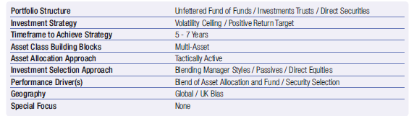

High level summary:

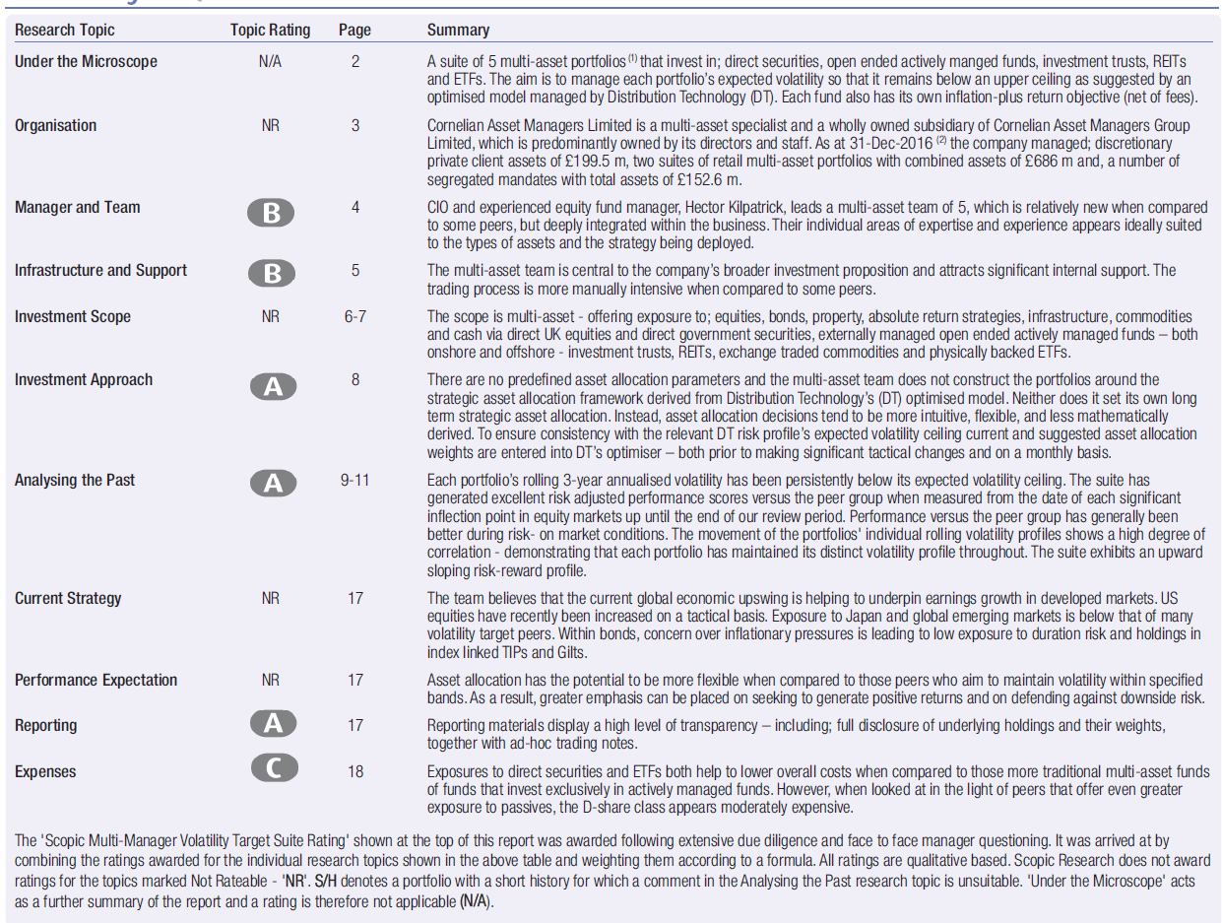

Appendix 6

**SEI Funds**

Range of funds aligned to risk and return expectations

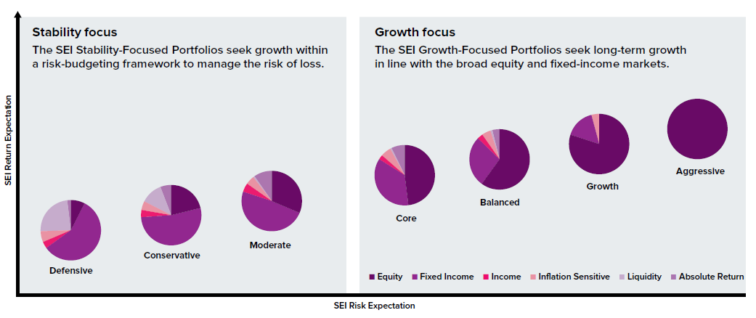

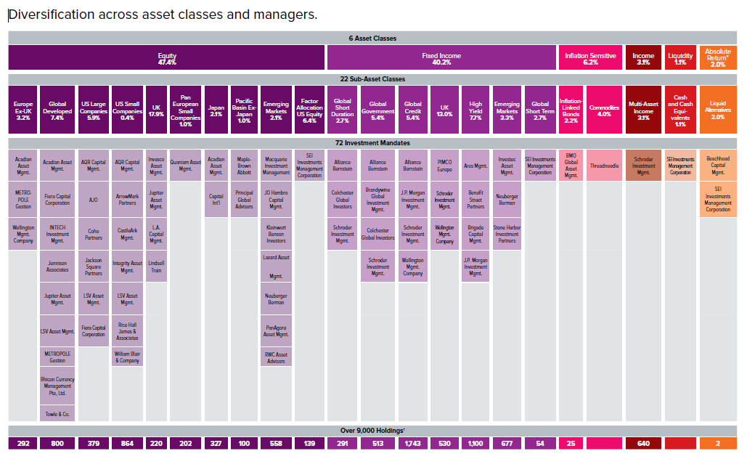

Appendix 7

**PruFund**

**Prudential Portfolio Management Group:**

The funds are constructed, monitored and reviewed by Prudential Portfolio Management group (PPMG) which at December 2016 controlled £170bn of Prudential’s Investments with the overall group investing over £599bn of client investments and have access to a large number of investment professionals around the world. (Documentation covering the approach to managing the funds, governance and controls is available to support this report).

**Financial Strength Ratings:**

The Prudential currently have ‘A’ ratings from AKG for all Pension and Bond contracts and B+ ratings for International Bonds.

**Explanation of the Funds:**

The Prufunds are based on the same multi-asset allocation process as the long-established Prudential With-Profits Fund which has existed since the 1950s.

The PruFunds were created in order to address the with-profits fund’s perceived lack of liquidity and transparency. The key difference from the with-profits fund is that instead of receiving an annual bonus the PruFund range has unit prices which are smoothed using a quarterly Expected Growth Rate (EGR). This EGR is then used to set a smoothed unit price over the quarter. While this smoothed growth rate is reassessed daily, the unit price will only deviate from the EGR under exceptional market circumstances, in which case Prudential will notify a suspension of smoothing.

In basic terms, the PruFund is smoothed quarterly, whereas the With-Profits fund is smoothed over several years. Consequently the PruFund range does not require ant Market Value Reduction (MVR) and hence is more transparent. However, it is still not as liquid or transparent as an OEIC or investment trust, and an early surrender penalty may still apply depending on which wrapper is used to access the fund.

The Risk Managed Prufunds are designed with different levels of investment risk and with specific equity exposure parameters. As a result, the output from the client risk profiling process should be able to match against the funds.

The Prufund range uses a multi-asset approach to aim for varying levels of return given a selection of asset allocation and implied risk levels. The EGR declarations made should provide advisers with a method of tracking the performance of the funds against their core aims and objectives therefore supporting the regular review process for clients.

**Appropriateness for clients:**

The philosophy typically positions the PruFunds as being suited to risk adverse client and as such is appropriate for those wishing to have some exposure to equity markets, but will typically have a low or moderate tolerance for investment volatility.

The PruFunds contain equity based investments and therefore are only suitable for long-term investment strategies.

The range of funds is as follows:

* PruFund Cautious and Protected Cautious
* PruFund Growth and Protected Growth
* PruFund 0-30 -High exposure to lower risk assets e.g. fixed interest securities, cash and money market instruments. No more than 30% of the fund is invested in equities
* PruFund 10-40 - Exposure to equities will be between 10% and 40%
* PruFund 20-55 - Between 20% and 55% will be invested in equities including both UK and International equities, property and other specialist investments.
* PruFund 40-80 – As per the 20-50 Prufund with 40% to 80% invested in equities.

**Guarantees:**

Clients investing in the PruFund Protected Cautious and Growth funds can elect to pay for a guarantee which will provide a degree of security against market falls. The term of the guarantee can be selected and depending on this, a % charge per annum it made. For example, in February 2016, for the PruFund Protected Cautious Fund over a 10 year term the cost would be 0.5% p.a.

**Expected Growth Rates:**

Prudential announced the EGRs that are to be applied to the PruFund Range of Funds every quarter. The EGR which applies to each fund is the annualised rate, which will be applied daily to increase the unit price of that fund.

These are set on a quarterly basis by the Prudential Assurance Company (PAC) Ltd directors and take into account the expected long-term investment returns on the assets of each fund.

The following tables show Prudential’s current EGRs gross of all bond product charges, including AMCs.

**Prudential Investment Plan (onshore bond)**

|  |  |  |  |  |  |  |
| --- | --- | --- | --- | --- | --- | --- |
| **Fund** | | **PruFund Growth**  **PruFund Protected Growth** | | | **PruFund Cautious**  **PruFund Protected Cautious** | |
| EGR | | 6.0% | | | 5.4% | |
| **Fund** | **PruFund 0-30** | | **PruFund 10-40** | **PruFund 20-55** | | **PruFund 40-80** |
| EGR | 5.2% | | 5.6% | 5.8% | | 6.1% |

Table 3

Approach to PruFunds – The following table has been produced by Defaqto and outlines the considerations for using with clients.

**Approaching PruFunds**

|  |  |
| --- | --- |
| Meeting a range of needs | PruFunds can be used to meet a range of investment and saving needs. They are most suitable for long-term, risk-averse investors. They can be used to support accumulation and decumulation strategies |
| Matching investment return requirements | The EGR approach can help advisers and clients to better understand their potential investment returns and hence enhance holistic financial planning and targeting. |
| Assessing attitude to risk, capacity for loss and required return | The FCA’s guidance consultation, ‘Assessing Suitabiltiy: Establishing the risk a customer is willing and able to take and making a suitable investment selection’, urges advisers to improve client risk profiling exercises by evaluating capacity for loss in addition to attitude to risk.  Subjects to consider include:   * Attitude to risk * Capacity for loss * Required return   The PruFunds can be used to tie-in with the risk profiling analysis |
| Accessing guarantees | Those clients seeking to guard against capital loss and further protect their retirement fund from market falls can consider engaging with the PruFund guaranteed funds |
| Mitigating investment market volatility | The multi-asset approach adopted by PPMG and fund guarantees can also contribute to de-risking client investment portfolios |
| Reducing the impact of withdrawals in falling markets | The smoothing processes and risk framework employed may help to reduce the threat of clients experiencing negative pound cost averaging within drawdown |
| Managing risk and equity exposure in the approach to retirement | ‘Automatic disinvestment’ and ‘life-styling’ mechanisms have been used within many tax wrappers to protect client investments from market downturns by moving assets out of equity markets and into cash and gilts in approach to a set date.  Potential downsides to this are that client may be less likely to benefit from market gains and the automated nature of these procedures may lack flexibility.  Advisers should continue to monitor a client’s attitude to risk, capacity for loss and required return and evolving personal circumstances on a regular basis- an activity encouraged by FCA guidance – and where necessary the PruFund Risk Managed framework can potentially be used to move the client up or down the risk scale in order to maintain suitability. |

Source: Defaqto