**Investment Philosophy and Approach**

**ABC Wealth Management** involves both enhancing and protecting wealth within a framework that is tailored to the individual requirements of the client. Investment is therefore a major part of the ABC Wealth Management proposition. We have developed a rigorous and well thought through investment process that has delivered both excellence and consistency within a philosophy that firmly places each individual at the centre of this process.

In our experience, many people have neither a plan nor a strategy when it comes to investing their money. We take considerable time working with our clients, to understand and agree clear goals and objectives, attitudes to risk and tolerance of loss, and then build and manage a portfolio that can adapt to reflect their on-going situation.

### Core Investment Strategies

We have developed an investment process that uses some of the most advanced techniques and academic thinking normally only utilised by major institutional investors. Our process takes the following steps:

* We initially review clients’ aims and objectives, in conjunction with clients’ financial planning adviser.
* We undertake a detailed analysis of clients’ approach to risk, and discuss and agree with clients the parameters that we will work in.
* We develop clients’ objectives into a strategic investment plan. This is designed to maximise clients’ return whilst ensuring that the risks taken are in line with clients’ appetite for such risk.
* We build clients’ portfolios, using both asset allocation and fund selection criteria as set out by our Investment Committee.
* We review both clients’ own objectives, including approach to risk, and the asset allocation and funds within the portfolio, on a regular basis.

### Investment Objectives

When building an investment portfolio, the primary consideration has to be a clear understanding of the objectives. For example, if the planning work identified that clients only require a return of 5% per annum to comfortably achieve clients’ income requirements, then why take more risks than clients have to. In such a situation, to strive for 15% pa instead, inevitably taking higher risks with the capital, would put the portfolio in danger of failing to meet the objectives. Of course, if the core objective can be achieved from only a part of the portfolio, then we can discuss whether the balance can be allowed to take a more unfettered, aggressive approach. There is no “one size fits all” process to how we manage our clients funds - it is a highly consultative approach.

It is this core belief, that portfolio management should be directly linked to careful financial planning, that stands at the centre of ABC’s philosophy.

### Portfolio Construction

The construction of our portfolios involves 4 key elements:-

* **Asset Allocation**, which is concerned with how clients spread investment between the main different asset classes– often referred to as Top Down.
* **Portfolio Design**, which determines how the portfolio should be sub-divided within asset classes, looking at geographic, economic and socio-political influences.
* **Investment Fund Selection**, which determines which specialist managers and funds are best suited to achieve the portfolios aims.

### Portfolio Construction and Risk Management

**Strategic Asset Allocation**

Asset allocation is the precise division of a portfolio between multiple asset classes, such as equities, fixed interest, property and cash.

The importance of strategic asset allocation to the long term volatility and returns of a portfolio has been consistently been demonstrated over the years through various academic studies. The conclusion is that asset allocation, not market timing or stock selection, is the primary factor in determining why different portfolios experience different results.

We have a dynamic asset allocation process, which is determined and managed by ABC’s Investment Committee, and which drives our portfolios. We have 5 risk- managed portfolios designed to fit our clients various risk tolerances. Each portfolio has trading parameters that are based around the minimum and maximum exposure we have to the equity markets – the higher the inherent risk of the portfolio, the higher the upper limit of equities we allow. The Investment Committee will vary this exposure within the tolerance levels of each portfolio, depending on its view of the prevailing market conditions across the Globe.

In reaching its decisions, the committee takes into consideration research from leading independent analytical and economic bodies, as well as the views of major investment commentators and managers. We also draw on academic research from both the US and the UK. Much still stems from work initiated by Nobel Prize winner, Harry Markowitz, in the 1950’s. He led the way on modern portfolio theory, which asserts that for every identifiable level of risk that exists, it is possible to construct an investment portfolio that will produce the required returns for investor within the relevant volatility expectations.

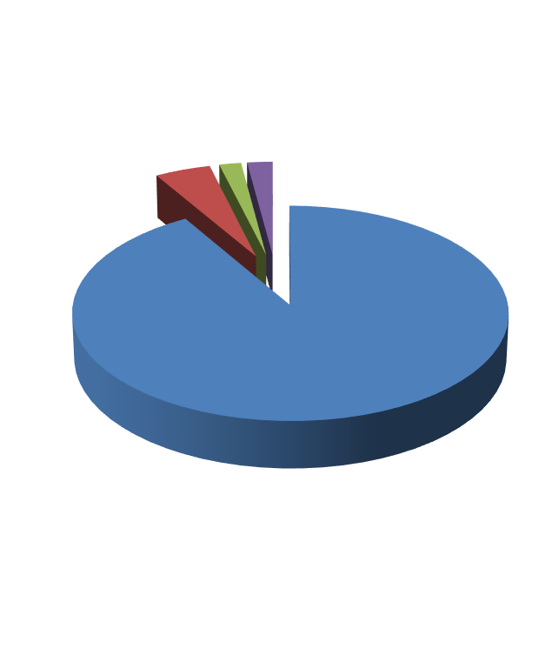**Sources of Portfolio Volatility and Returns**

Asset Allocation Security Selection Market Timing Other

Source: Brinson et al 1991, ‘Determinants of Portfolio Performance’ Financial Analyst Journal May 1991. Past performance is no indication of future returns

**Portfolio Design**

The division of assets is only the beginning of the asset allocation story. To access the return potential of the financial markets and potentially reduce risk, a portfolio should also be diversified within asset classes, and should identify the investment approach taken by an active fund manager in an effort to generate excess returns.

Geographic

Spread

Themes

-Global & Local

Diversified Portfolio

Asset Class

-Equities, Debt, Property, Cash

Stock Picking Style

- Value, Growth, Active, Passive

ABC’s decisions are based on our own convictions and views of the world, combined with extensive research, both internal and outsourced. The ABC Investment Committee aims to enhance returns and reduce risk by blending the asset mix based upon current Macro and Micro economic, geo-political and social themes.



* Geographic Spread
* Economic & Political
* Currency
* Value/Growth
* Interest Rate Cycle
  + Credit Risk
  + Duration

Equities

Debt

Property

Alternatives

* Yield
* Growth
* Economic cycle
* Liquidity
* Thematic Influences
  + Hedging strategies
    - Commodities
      * Liquidity

**Investment Fund Selection**

We seek to identify Funds and Fund Managers that can deliver repeatable performance, and to differentiate manager “skill” from “luck”.

The investment opportunities available across the world are vast are almost limitless. We do not believe that any one investment manager or investment company can have all of the answers. Our Asset Allocation process identifies the key geographic, asset class and global themes, and within each of these sectors, part of our role is then to identify how best to maximise the returns and manage the risk. We look for diversification of risk, cost effectiveness and specialist knowledge where necessary.

Rather than use direct investment, therefore, our preference is to use a mixture of active and passive Collective Investments funds. These are professionally managed structures, such as Open Ended Investment Company Schemes (OEICS) and Unit

Trusts, and allow us to mandate out to specialists, giving our clients’ diversification within each sector that could not otherwise be obtained and access to expert knowledge within our chosen sectors.

### Fund Selection is a key element in our ability to identify active funds that will perform in line with our expectations. Understanding the approach, philosophy, methodology, risk management techniques and the skill and motivation of the fund manager, is therefore crucial. Our fund selection process is detailed, and involves a combination of qualitative analysis (studying the facts and figures behind a fund and it’s historic performance) and qualitative analysis (understanding the process and approach of the manager and his team, and the positioning of the fund for the future).

**Combining Active and Passive Funds**

Active management refers to an investment approach taken by a fund manager that aims to outperform the market average by using their knowledge and skill to identify shares which they believe are undervalued, and avoid shares which they believe will do badly.

However, there has been a great deal of academic independent research undertaken on the viability of active management. The statistics that these studies have produced demonstrates that, on average, the majority of active investment managers fail to beat the broad market benchmark over the long term.

However, this does not tell the whole story. Many of the ‘so-called’ Active Managers are either pseudo tracking funds, but nevertheless charge higher fees and are therefore destined to always underperform (we call these the ‘Lazy’ managers). There are also a large number of funds that are, for one reason or another, dormant funds and not open to new investment (we call these the ‘dead’ funds). When we remove the ‘lazy’ and the ‘dead’ from the statistics, it is quite clear that there are fund managers who do consistently beat the index.

The main argument in favour of Index or Passive funds is to do with cost. Passive funds, which essentially track their index by replicating the underlying holdings, are driven by computer models and require no expensive fund manager input. As such, they are often significantly cheaper that their ‘active’ counter-parts.

In choosing an active manager as part of our portfolio, therefore, we have to be convinced that they can out-perform the index by enough of a margin to justify their costs, and do it repeatedly.

One additional fact that is often not understood is that fund managers will often offer funds into the retail market that are priced to reflect the costs of distribution, but will also provide the same fund at a discounted cost for use by the institutional market. They do this because the size of the investments are considerably higher and therefore their costs of distribution are commensurately lower.

### By using a combination, both Active and Passive funds, and by using our strong relationship with many of the fund managers to be able to access institutionally priced vehicles for our clients, our portfolio’s offer a number of key benefits:

**Investment Fund Selection Process**

Quantitative Analysis

* Universe of 70,000 funds
* Outsourced research carried out by specialist rating and analytical firms

Fundamental Analysis

* c.300 Funds
* Internal and external analysis
* Portfolio characteristics, track record

Qualitative Analysis

* 70-100 Fund Manager meetings per year
* Repeatable Process
* Stability

Core Holdings

* On-going Monitoring and visits



Active Funds to gain ‘Alpha’ performance over the market average

Fund Mix

Passive and Institutional Active funds to keep costs low

Passive funds to capture market returns

# **Portfolio Construction and Risk Management**

Return

We build our portfolios around clients’ overall objectives and risk tolerances. Effective risk management is core to our approach, and we carefully analyse the volatility and diversification within each clients portfolio, and work with the clients financial planning adviser to ensure that the correct mix of defensive and growth based strategies are incorporated into the portfolio to maximise returns whilst minimising volatility.

Growth Engine

?

**Clients’ portfolio**

Defensive Safety Net

Risk

Clients’ financial need to take risk to meet clients’ goals

Clients’ emotional tolerance to risk

# **Selecting the level of risk clients are willing and able to take**

» Establishing which portfolio structure is most suitable for clients is a critical decision.

» It is a function of clients’ tolerance for risk, clients’ financial capacity to absorb losses, and clients’ financial need to take it.

» It requires insight, discussion and a decision that clients feel comfortable with.

* 1. Attitude to risk

How much investment risk can clients emotionally take?



Aggressive (100%/0%)

Moderately Aggressive (80%/20%)

Moderate (60%/40%)

Conservative (40%/60%)

Very Conservative

(20% Return Engine, 80% Defensive)

1.. Return target 4. Consultative and educational approach

Clients’ financial goals, lifestyle costs, and asset base.

Understanding and agreeing the level of risk clients are willing and able to take

* 1. How much risk can clients absorb?

What is clients’ financial capacity to absorb losses?

Potential return

Risk

**Investment Governance Process**

* Quarterly Investment Committee Meetings



Advisers

Executive & Management Board

Investment Committee

Strategy Oversight Implementation

* Bi-weekly market and fund updates
* Daily market contact and research

Chief Investment Officer Investment Manager Research Analysts Compliance Officer



Roles



Follow-up

Agendas Implementation



Fund manager movements FCA requirements Management information Risk management

Efficacy of Process Latest research Best-in-class review Asset class review

New product due diligence



Reporting

Accountability

**ABC’s Strategic Portfolios**

ABC’s Strategic Portfolios provide investors with five core investment options designed to meet a wide range of financial goals. The portfolios are designed to give clients a rigorous and objective investment approach with the aim of maximising returns, limiting volatility

Focus: Wealth Preservation

Stock-market

Adventurous

Balanced

Conservative

Focus: Wealth Accumulation

Cautious

UK Equity

Global Equity Fixed Interest Property

Absolute Return

Commodity

and managing investment

risk.

Expected Risk

Expected Return

**Our role as clients’ investment**

**Planning**



Build a suitable portfolio Need for risk

Capacity for risk Tolerance for risk

**Planning Process**

**Investment process** Intelligent Investing Robust decisions Minimise costs Minimise emotions Risk management

IFA

## Governance

**Governance process**

Robust decisions on clients’ behalf Best solution

Protection of clients’ wealth Stewardship over time